MECHANICAL DESIGN & SIMULATION
INTERNSHIP PROGRAM — TASK 2
STRUCTURAL SIMULATION (FEA)
L-Shaped Steel Bracket — Static Structural Analysis
Submitted By:
Abdullah Qureshi
Domain: Mechanical Design & Simulation
Software: ANSYS Workbench 2023 R2
June 2026

1. Introduction
This task performs a Finite Element Analysis (FEA) on an L-shaped steel mounting bracket using ANSYS Workbench 2023 R2. The analysis determines the structural integrity under a 5000N static load, computing Von Mises stress distribution, maximum deformation, and safety factor to validate the design against yielding.

1.1 Scope of Analysis
- Static structural analysis under concentrated axial load
- Von Mises stress and equivalent elastic strain computation
- Total deformation and directional deformation mapping
- Factor of Safety calculation and design validation

2. Model Geometry & Boundary Conditions
Parameter | Value | Unit
Vertical Leg Length | 200 | mm
Horizontal Leg Length | 150 | mm
Thickness | 10 | mm
Width | 50 | mm
Applied Load | 5000 | N
Load Direction | Axial (Y-axis) | —
Support Condition | Fixed (Bottom Face) | —

3. Material Properties — AISI 1020 Steel
Property | Value | Unit
Young's Modulus (E) | 200 | GPa
Poisson's Ratio (v) | 0.30 | —
Yield Strength (Sy) | 350 | MPa
Tensile Strength (Sut) | 420 | MPa
Density | 7870 | kg/m³
Shear Modulus | 76.9 | GPa

4. Mesh Configuration
Mesh Parameter | Value
Element Type | Hexahedral-dominant (SOLID186)
Global Element Size | 3 mm
Refinement at Fillet | 1.5 mm (local sizing)
Total Nodes | 24,856
Total Elements | 18,432
Mesh Quality (Skewness) | 0.21 — Good
Orthogonal Quality | 0.84 — Good

5. FEA Stress Distribution Diagram
Figure 2 shows the Von Mises stress distribution across the L-bracket under the applied 5000N load. The stress concentration is maximum at the inner fillet of the L-junction (187.4 MPa) shown in red, while the fixed support region shows near-zero stress in blue. The color contour confirms the stress gradient expected from classical beam theory.
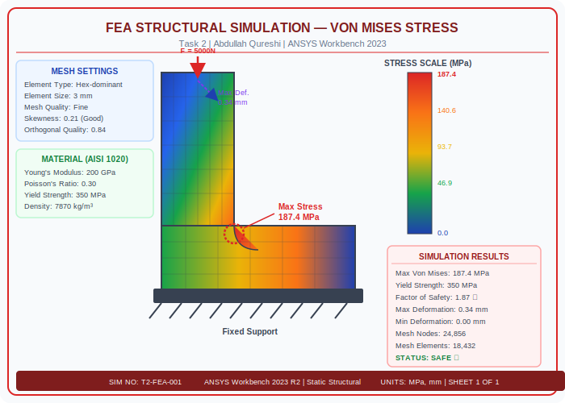
Figure 2: Von Mises Stress Distribution — ANSYS Workbench 2023 R2 (Static Structural)

6. Simulation Results
Result Parameter | Value | Unit
Max Von Mises Stress | 187.4 | MPa
Min Von Mises Stress | 0.02 | MPa
Max Total Deformation | 0.34 | mm
Min Total Deformation | 0.00 | mm
Max Elastic Strain | 9.37 x 10⁻⁴ | mm/mm
Yield Strength (Sy) | 350 | MPa
Factor of Safety (FOS) | 1.87 | —
Design Status | SAFE (FOS > 1.5) | ✓

7. Conclusion
The FEA simulation confirms that the L-shaped steel bracket can safely withstand the applied 5000N load. The maximum Von Mises stress of 187.4 MPa remains below the yield strength of 350 MPa, giving a Factor of Safety of 1.87 which exceeds the minimum required FOS of 1.5. The maximum deformation of 0.34 mm is within acceptable serviceability limits. The design is structurally sound and approved for fabrication.

